Civil war in Sierra Leone

UNSC Resolution: | 1231
Date of adoption: | 11 March 1999
Operative paragraph: | 3
Demand number: | 1

Megan MacKenzie

Wording of demand

Investigate all allegations of such violations with a view to bringing the perpetrators of such violations to justice [atrocities against women and children, violations of human rights]

List of addressees of the demand

Government of Sierra Leone

Short-term compliance

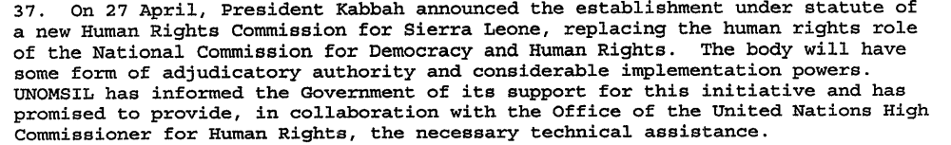

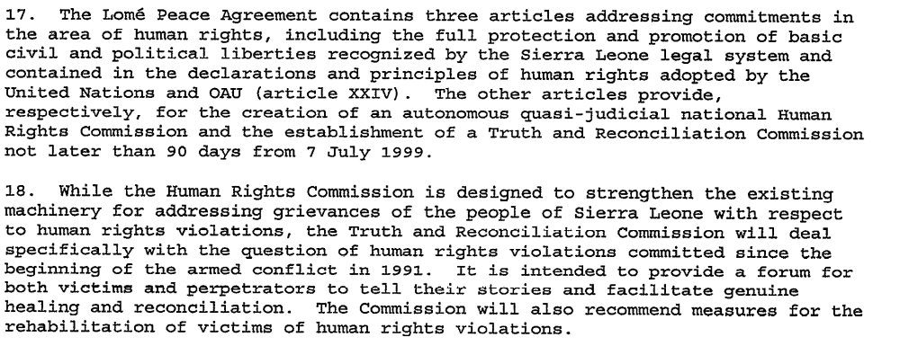

Assessment

Short-term compliance
No or marginal compliance (1) | Medium low compliance (2) | x Medium high compliance (3) | Full or almost full compliance (4)

Considerations underlying the assessment
The Government of Sierra Leone had a limited capacity to investigate allegations of human rights abuses but they made an attempt to create bodies that could address human rights abuses. The demand specifies that the Government have a view of bringing the perpetrators of such violations to justice; yet, the TRC was not a body that could do this.

Medium-term compliance

Assessment
5. The negotiations with the Government of Sierra
Leone, represented by the Attorney General and the
Minister of Justice, were conducted in two stages. The
first stage of the negotiations, held at United Nations
Headquarters from 12 to 14 September 2000, focused
on the legal framework and constitutive instruments
establishing the Special Court: the Agreement between
the United Nations and the Government of Sierra
Leone and the Statute of the Special Court which is an
integral part thereof. (For the texts of the Agreement
and the Statute, see the annex to the present report.)

Medium-term compliance
No or marginal compliance (1) | Medium low compliance (2) | x Medium high compliance (3) | Full or almost full compliance (4)

Considerations underlying the assessment
The demand specifically asked for the investigation of “all allegations of such violations.” In many ways this is an almost impossible demand, given the widespread and long term violations of human rights by multiple parties. However, great effort was made to establish the Special Court of Sierra Leone in order to investigate allegations of serious human rights abuses and violations of international law.

Depth of demand

Assessment

Level of depth of demand
Low depth of demand (1) | Medium depth of demand (2) | x High depth of demand (3)

Considerations underlying the assessment
Using the word “all” in this demand made this a high level demand. Complying fully with the demand would have required extensive investigations and a great deal of resources.

Level of confidence about coding decisions

Level of confidence about coding decision
Extremely high | x High | Moderate

Comments to IPI (if any)

Civil war in Sierra Leone

UNSC Resolution: | 1231
Date of adoption: | 11 March 1999
Operative paragraph: | 4
Demand number: | 1

Megan MacKenzie

Wording of demand

respect human rights and international humanitarian law and the neutrality and impartiality of humanitarian workers, and ensure full and unhindered access for humanitarian assistance to affected populations

List of addressees of the demand

Government of Sierra Leone, Armed Forces Revolutionary Council, Civil Defence Forces , Revolutionary United Front

Short-term compliance

Assessment

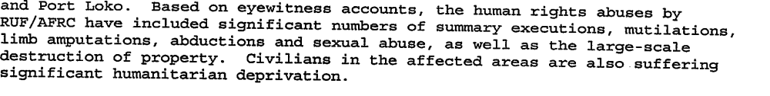
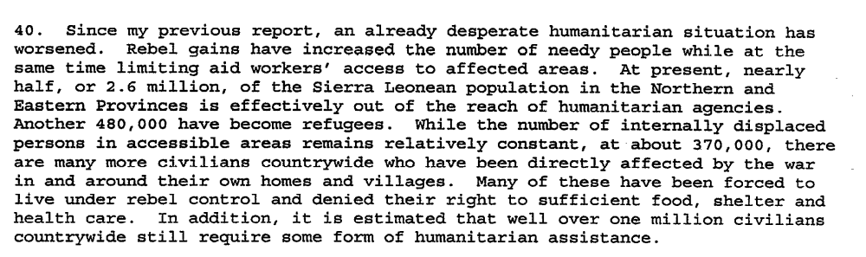
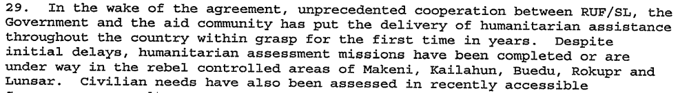

Short-term compliance
x No or marginal compliance (1) | Medium low compliance (2) | Medium high compliance (3) | Full or almost full compliance (4)

Considerations underlying the assessment
The Secretary General’s reports clearly indicate that human rights violations may actually have escalated in some areas during this period. There is clear indication that the parties did not comply with this demand.

Medium-term compliance

Description of the addressee(s)’ conduct

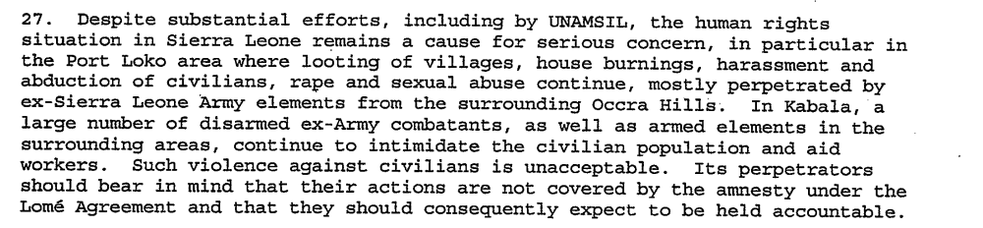
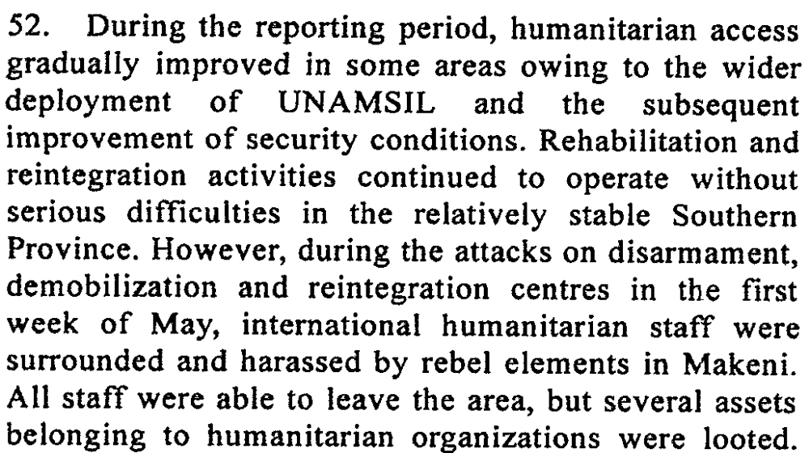

Assessment

Medium-term compliance
No or marginal compliance (1) | x Medium low compliance (2) | Medium high compliance (3) | Full or almost full compliance (4)

Considerations underlying the assessment
There is some indication that the security situation in various regions was improving and that humanitarian access was being facilitated. Despite this, there is also evidence of violence and human rights abuses.

Depth of demand

Assessment

Level of depth of demand
Low depth of demand (1) | Medium depth of demand (2) | x High depth of demand (3)

Considerations underlying the assessment
This was a period characterized by chaos, violence and human rights abuses. By asking the parties to respect human rights and international law as well as facilitating humanitarian access, the UN was demanding that the parties alter their behavior substantially.

Level of confidence about coding decisions

Level of confidence about coding decision
Extremely high | x High | Moderate

Comments to IPI (if any)

Civil war in Sierra Leone

UNSC Resolution: | 1231
Date of adoption: | 11 March 1999
Operative paragraph: | 9
Demand number: | 1

Megan MacKenzie

Wording of demand

participate seriously in these efforts [dialogue between fighting forces]

List of addressees of the demand

Government of Sierra Leone, Armed Forces Revolutionary Council, Civil Defence Forces , Revolutionary United Front

Short-term compliance

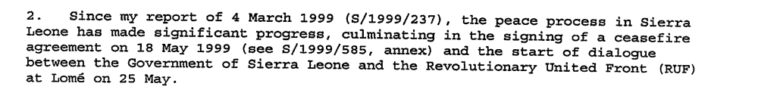
Not a direct quote: By mid year (1999) the government and the RUF has signed two negotiated settlements. Kabbah offered to rescind Sankoh’s death sentence if Sankoh would commit the RUF to a peaceful end to the civil war. Sankoh accepted. Peace negotiations commenced in Togo.

Assessment

Short-term compliance
No or marginal compliance (1) | Medium low compliance (2) | Medium high compliance (3) | x Full or almost full compliance (4)

Considerations underlying the assessment

It is clear from my research that the fighting forces were attempting to participate in dialogue.

Medium-term compliance

Description of the addressee(s)’ conduct

Sierra Leone's rebel Revolutionary United Front say they will fight rather than negotiate unless their leader, Foday Sankoh, is released.
Mr Sankoh was captured by Sierra Leone police in the capital on Wednesday - a week after he fled his Freetown home when rebels shot and killed 19 people protesting at the capture of UN peacekeepers… Mr Massakoi [RUF spokesman] told the French AFP news agency: "We will answer force with force and dialogue with dialogue.
"We want to go back to the negotiating table to make sure that all parties comply with what they signed."
Mr Massakoi said the RUF was committed to the 1999 Lome peace accord, which granted rebels full amnesty for horrific atrocities committed during the brutal eight-year civil war, and gave their leader vice-presidential status in a power-sharing government.
7. The Government of Sierra Leone has established its own indirect contacts with RUF, primarily through traditional leaders and relatives. However, the slow pace at which RUF is implementing aspects of the Abuja Agreement, which were intended to build confidence and pave the way for a political dialogue, has not helped to remove the deep apprehension about the rebels’ intentions.
For months after the Peace Agreement was signed, the RUF complained persistently that the CDF were secretly training fighters in the southern towns of Gbangbatoke and Bonthe in order to launch an attack against them. Whereas the AFRC and RUF had once been allies, the CDF and RUF generally remained sworn enemies, despite instances of peaceful, though wary, co-existence in some mining areas. During the war, the CDF constituted the backbone of resistance to the rebellion. Stories from the warfront ascribe to the CDF a capacity to unleash terror and commit atrocities comparable to those of the RUF, which has contributed to the mistrust and suspicion between the two armed factions.
The examples cited above are part of a larger web of suspicion that seemed to haunt the peace process. Illustrative of this are perceptions of the relationship between Sankoh and chief Samuel Hinga Norman, national coordinator of the CDF and Deputy Defence Minister. They are seen as two old army boys both implicated in coups in the 1960s and 1970s; as knowing each other well from their army days; as rumoured to have worked together for a while in Liberia to plan the 1991 insurgency against the APC government; and as subsequently finding themselves on opposite sides in the rebel war.

Assessment

Medium-term compliance
No or marginal compliance (1) | x Medium low compliance (2) | Medium high compliance (3) | Full or almost full compliance (4)

Considerations underlying the assessment

Committing to dialogue was not a significant commitment for the parties. Parties could behave in provocative or problematic ways but still show signs of commitment to dialogue and still meet the requirements of this demand.

Depth of demand

Assessment

Level of depth of demand
Low depth of demand (1) | x Medium depth of demand (2) | High depth of demand (3)

Considerations underlying the assessment

There is sufficient research indicating dialogue between the Government of Sierra Leone and the RUF; however, it was difficult to find information about the CDF and their behavior. Although the RUF and AFRC were still committing acts of violence during this period, it does appear that they were attempting to participate in dialogue.

Level of confidence about coding decisions

Level of confidence about coding decision
Extremely high | x High | Moderate

Comments to IPI (if any)

Civil war in Sierra Leone

UNSC Resolution: | 1245
Date of adoption: | 11 June 1999
Operative paragraph: | 3
Demand number: | 1

Megan MacKenzie

Wording of demand
remain committed to the process of negotiation and demonstrate flexibility in their approach to the process

List of addressees of the demand

Government of Sierra Leone, Revolutionary United Front

Short-term compliance

Description of the addressee(s)’ conduct
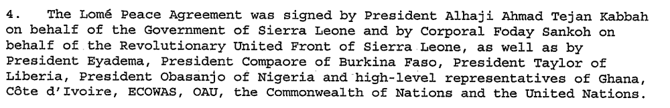
Sierra Leone's rebels have reached a peace agreement with Freetown to share power in a national unity government. "An agreement has been reached," said the source in the Togolese capital, who asked not to be named.
For more than a month, Revolutionary United Front (RUF) rebels have held peace talks here with President Ahmad Tejan Kabbah's government.

Assessment

Short-term compliance
No or marginal compliance (1) | Medium low compliance (2) | Medium high compliance (3) | x Full or almost full compliance (4)

Considerations underlying the assessment

This was a very positive period of time. The dialogue between RUF and the Government of Sierra Leone resulted in the signing of a significant peace agreement.

Medium-term compliance

Description of the addressee(s)’ conduct

Sierra Leone's rebel Revolutionary United Front say they will fight rather than negotiate unless their leader, Foday Sankoh, is released.
Mr Sankoh was captured by Sierra Leone police in the capital on Wednesday - a week after he fled his Freetown home when rebels shot and killed 19 people protesting at the capture of UN peacekeepers… Mr Massakoi [RUF spokesman] told the French AFP news agency: "We will answer force with force and dialogue with dialogue.
"We want to go back to the negotiating table to make sure that all parties comply with what they signed."
Mr Massakoi said the RUF was committed to the 1999 Lome peace accord, which granted rebels full amnesty for horrific atrocities committed during the brutal eight-year civil war, and gave their leader vice-presidential status in a power-sharing government.
7. The Government of Sierra Leone has established its own indirect contacts with RUF, primarily through traditional leaders and relatives. However, the slow pace at which RUF is implementing aspects of the Abuja Agreement, which were intended to build confidence and pave the way for a political dialogue, has not helped to remove the deep apprehension about the rebels’ intentions.

Assessment

Medium-term compliance
No or marginal compliance (1) | x Medium low compliance (2) | Medium high compliance (3) | Full or almost full compliance (4)

Considerations underlying the assessment
The Government of Sierra Leone remained committed to the Lome accord; however, the RUF clearly violated the agreement and did not behave as if they were committed to peace. There were only piecemeal efforts made by the RUF to work towards peace during this period and ultimately the parties were forced to enter a new peace agreement.

Depth of demand

Assessment

Level of depth of demand
Low depth of demand (1) | x Medium depth of demand (2) | High depth of demand (3)

Considerations underlying the assessment

Remaining committed and flexible are two distinct demands that assume a higher level of dedication than dialogue. It implies that the parties must be willing to alter their behavior or expectation in order to facilitate the peace process.

Level of confidence about coding decisions

Level of confidence about coding decision
Extremely high | High | x Moderate

Comments to IPI (if any)

Civil war in Sierra Leone

UNSC Resolution: | 1260
Date of adoption: | 20 August 1999
Operative paragraph: | 2
Demand number: | 1

Megan MacKenzie

Wording of demand

ensure that the provisions of the Agreement are fully implemented

List of addressees of the demand

Government of Sierra Leone, Revolutionary United Front

Short-term compliance

Description of the addressee(s)’ conduct

While Foday Sankoh remained in charge of the RUF, it continued to be an unreliable partner for peace. In the months following Lome [July 1999], the RUF became increasingly obstructionist, restricting the movement of UN troops and humanitarian staff in the rebel-controlled eastern and northern parts of the country. Cease-fire violations were common.

Rebels in Sierra Leone are continuing to carry out atrocities against civilians, according to a letter published today by an international human rights group. New York-based Human Rights Watch says it has documented many recent rebel violations including rape, torture, looting and mutilations, despite a recent peace accord…. Many of the recent abuses documented were committed here [Makeni], and at least 100 fighters are reported to have been killed in the fighting.

Assessment

Short-term compliance
x No or marginal compliance (1) | Medium low compliance (2) | Medium high compliance (3) | Full or almost full compliance (4)

Considerations underlying the assessment
Although the Government remained committed to the peace process, there were significant and obvious actions by the RUF that inhibited the implementation of the peace process and, in fact, further destabilized the country.

Medium-term compliance

Description of the addressee(s)’ conduct

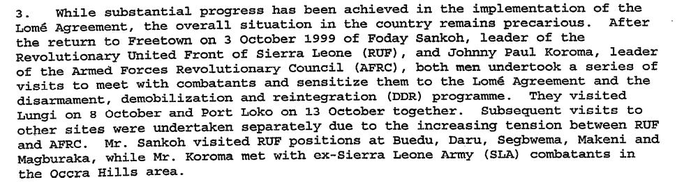
RUF Leader Foday Sankoh, who, under the Lomé agreement, had been pardoned of a treason conviction, granted the status of vice president and given the chairmanship of a Commission for the Management of Strategic Resources, was eventually taken prisoner after fleeing a Freetown demonstration protesting the RUF's lack of compliance with the peace agreement. The Sierra Leone government subsequently sought UN and other international backing to establish a tribunal to try Sankoh and others for crimes against humanity.
While the security situation within Sierra Leone deteriorated dramatically in May, in large part because of the recalcitrance of the RUF and other anti-government fighters to disarm, the demobilization, disarmament and reintegration program and other mechanisms established under the Lomé agreement had made some progress - despite poor planning and lack of human and financial resources. By the beginning of May approximately 24,000 combatants of an estimated total of 45,000 had entered the program. The Commission for the Consolidation of Peace had also begun to undertake field activities with mid-level force commanders that showed considerable promise of accelerating and deepening the disarmament and reintegration process.

Assessment

Medium-term compliance
x No or marginal compliance (1) | Medium low compliance (2) | Medium high compliance (3) | Full or almost full compliance (4)

Considerations underlying the assessment
The disarmament process was initiated and the RUF were given positions in the Government as a result of the Lome; however, fighting continued and the Government of Sierra Leone did not uphold their provision of amnesty for RUF rebels. The demand asks for full implementation and this did not happen.

Depth of demand

Assessment

Level of depth of demand
Low depth of demand (1) | Medium depth of demand (2) | x High depth of demand (3)

Considerations underlying the assessment
There were significant expectations associated with full implementation of the accord for all parties. Cessation of fighting, disarmament, including RUF members into the government, and granting amnesty all involved drastic changes in the parties’ behaviors.

Level of confidence about coding decisions

Level of confidence about coding decision
Extremely high | x High | Moderate

Comments to IPI (if any)

Civil war in Sierra Leone

UNSC Resolution: | 1260
Date of adoption: | 20 August 1999
Operative paragraph: | 5
Demand number: | 1

Megan MacKenzie

Wording of demand

respect fully the status of United Nations and associated personnel

List of addressees of the demand

Government of Sierra Leone, Armed Forces Revolutionary Council, Civil Defence Forces , Revolutionary United Front

Short-term compliance

Description of the addressee(s)’ conduct
While Foday Sankoh remained in charge of the RUF, it continued to be an unreliable partner for peace. In the months following Lome [July 1999], the RUF became increasingly obstructionist, restricting the movement of UN troops and humanitarian staff in the rebel-controlled eastern and northern parts of the country. Cease-fire violations were common.

In the months after the Lome accord was signed, the United Nations slowly assembled a peacekeeping force intended to take the place of a Nigerian-led, largely West African force that had recaptured Sierra Leone's capital, Freetown, from the rebels early in 1999.
But when the last of the Nigerian troops withdrew in early May, the rebels swiftly overran several positions of United Nations peacekeepers, taking nearly 500 of them hostage. Most hostages were released after negotiations with Charles Taylor, the president of neighboring Liberia, and after Britain, the former colonial power in Sierra Leone, sent troops to help restore order.

The Lomé agreement collapsed in May 2000. The RUF was chiefly to blame,
sabotaging the peace process by capturing 500 UN peacekeepers and their
equipment. P3

Assessment

Short-term compliance
x No or marginal compliance (1) | Medium low compliance (2) | Medium high compliance (3) | Full or almost full compliance (4)

Considerations underlying the assessment
This was a major breach in confidence between the rebel forces and the UN. Not only did the RUF kidnap and injure UN peacekeepers, it took a considerable amount of time to negotiate the release of these peacekeepers.

Medium-term compliance

Description of the addressee(s)’ conduct

The Lomé agreement collapsed in May 2000. The RUF was chiefly to blame,
sabotaging the peace process by capturing 500 UN peacekeepers and their
equipment. P3

May 2000 RUF rebels took over 400 UN peacekeepers hostage p141

30 June: One Jordanian peacekeeper was killed and four wounded Friday when an escort group of five vehicles of the Jordanian UNAMSIL contingent was ambushed by unknown attackers about 20 kilometres west of Mile 91, a U.N. spokesman said. According to the spokesman, the Jordanian convoy was returning from Kenema to Freetown when it was came under attack at about 1:30 p.m. local time.

Assessment

Medium-term compliance
x No or marginal compliance (1) | Medium low compliance (2) | Medium high compliance (3) | Full or almost full compliance (4)

Considerations underlying the assessment

During this period, extensive negotiations took place for the release of UN peacekeepers. Even after they were released, there is evidence that peacekeepers faced threats to themselves and their equipment.

Depth of demand

Assessment

Level of depth of demand
Low depth of demand (1) | Medium depth of demand (2) | x High depth of demand (3)

Considerations underlying the assessment

It was difficult to decide if this should be a high or medium depth. For the RUF, respecting the UN mission required a marked change in their behaviors.

Level of confidence about coding decisions

Level of confidence about coding decision
Extremely high | High | x Moderate

Comments to IPI (if any)

This is one of many demands where the rebel fighting factions and the Government of Sierra Leone are both addressed in the demand, yet the behavior of these parties are completely different. Often it is the RUF that are the sole – or the most obvious- violators of the demands.

Civil war in Sierra Leone

UNSC Resolution: | 1260
Date of adoption: | 20 August 1999
Operative paragraph: | 7
Demand number: | 1

Megan MacKenzie

Wording of demand

ongoing consultations among the parties concerned on future peacekeeping arrangements in Sierra Leone including the respective tasks, strength and mandates of ECOMOG and the United Nations

List of addressees of the demand

Government of Sierra Leone, Armed Forces Revolutionary Council, Civil Defence Forces , Revolutionary United Front

Short-term compliance

Description of the addressee(s)’ conduct

While Foday Sankoh remained in charge of the RUF, it continued to be an unreliable partner for peace. In the months following Lome [July 1999], the RUF became increasingly obstructionist, restricting the movement of UN troops and humanitarian staff in the rebel-controlled eastern and northern parts of the country. Cease-fire violations were common.

In the months after the Lome accord was signed, the United Nations slowly assembled a peacekeeping force intended to take the place of a Nigerian-led, largely West African force that had recaptured Sierra Leone's capital, Freetown, from the rebels early in 1999.

Assessment

Short-term compliance
x No or marginal compliance (1) | Medium low compliance (2) | Medium high compliance (3) | Full or almost full compliance (4)

Considerations underlying the assessment
There is not much evidence of negotiation during this period. It was marked by ceasefire violations and set-backs to the peace process.

Medium-term compliance

Description of the addressee(s)’ conduct

In his address to the summit, President Kabbah indicated that the new troops should be separate from, and work alongside, U.N. peacekeepers. "ECOMOG still has a job to do in Sierra Leone," he said, adding that it should work in a "partnership for peace and security" with the U.N. "What we need is a joint effort — national, regional and international — to achieve peace and security in Sierra Leone," he said.

Former RUF field commander Sam "Mosquito" Bockarie has accused Britain of prolonging the war in Sierra Leone. In a Reuters interview published on Saturday, Bockarie insisted that the RUF was still a force to be reckoned with. "It is Britain that has prolonged the war in Sierra Leone, because they do not want to bring in the right procedure to bring lasting peace," Bockarie said. "No troops can defeat the RUF on the ground." Bockarie went into exile in Liberia in December following a public rift with RUF leader Foday Sankoh. "I was insisting that the ECOMOG leave and the U.N. should deploy simply because I knew we had fought the Nigerians for the past six or seven years," Bockarie said. "We felt if the Nigerians remained to maintain peace there, it wasn't going to be peace — we would fight, like what is happening now."

Assessment

Medium-term compliance
No or marginal compliance (1) | x Medium low compliance (2) | Medium high compliance (3) | Full or almost full compliance (4)

Considerations underlying the assessment
The Government of Sierra Leone clearly established a positive relationship with ECOMOG and the UN mission; however, the RUF consistently challenged the authority of the UN mission and the presence of ECOMOG forces.

Depth of demand

Assessment

Level of depth of demand
Low depth of demand (1) | x Medium depth of demand (2) | High depth of demand (3)

Considerations underlying the assessment

For the Government, negotiating with the UN mission and ECOMOG was primarily in their interests while the RUF saw these parties as a threat to their existence. There is not much evidence related to the CDF and their behavior and attitude towards these parties.

Level of confidence about coding decisions

Level of confidence about coding decision
Extremely high | High | x Moderate

Comments to IPI (if any)
The Secretary General Reports, along with other major resources, tend to focus on Government and RUF activity much more than the activity of the CDF. I would have been more confident in some of my coding decisions if I had more evidence of the CDF’s behavior.

Civil war in Sierra Leone

UNSC Resolution: | 1260
Date of adoption: | 20 August 1999
Operative paragraph: | 8
Demand number: | 1

Megan MacKenzie

Wording of demand
begin immediately to disband and give up their arms in accordance with the provisions of the Peace Agremeent, and participate fully in the disaramament, demobilization and reintegration programme in Sierra Leone

List of addressees of the demand

Government of Sierra Leone, Armed Forces Revolutionary Council, Civil Defence Forces , Revolutionary United Front

Short-term compliance

Description of the addressee(s)’ conduct
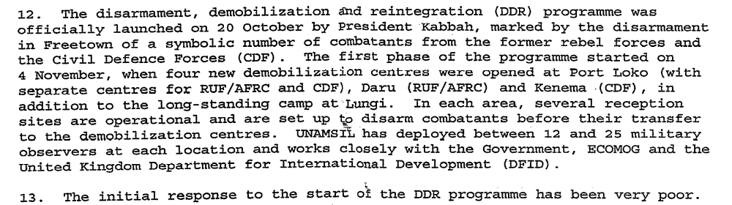
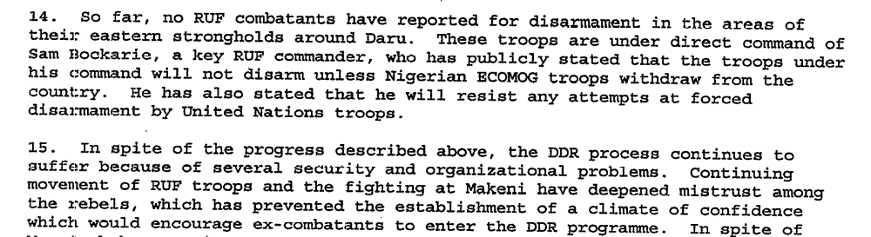

Assessment

Short-term compliance
No or marginal compliance (1) | Medium low compliance (2) | x Medium high compliance (3) | Full or almost full compliance (4)

Considerations underlying the assessment
Although there were reported problems and delays with the disarmament process for all parties, the demand asks for the beginning of the disarmament process and it was clear that this process was initiated.

Medium-term compliance

Description of the addressee(s)’ conduct

In January 2000 Foday Sankoh “told a gathering of his RUF fighters [in English]….to cooperate with the disarmament process” in front of UN staff. Later he told them in Temne and Mende not to disarm.

For months since signing the Lomé peace agreement that formally ended the country's eight-year civil war in July 1999, the RUF has failed to live up to its promise to demobilize its forces and disarm, a key requirement of the peace accord. As of April 15, according to the National Committee for Disarmament, Demobilization, and Reintegration, only some 5,000 weapons had been handed in by Sierra Leonean rebels, who reportedly number approximately 45,000, and most of those appear to have been surrendered by members of Sierra Leone's former army rather than by RUF fighters.

Assessment

Medium-term compliance
No or marginal compliance (1) | x Medium low compliance (2) | Medium high compliance (3) | Full or almost full compliance (4)

Considerations underlying the assessment

The disarmament process was operating but there is evidence that the RUF were not participating fully in the process.

Depth of demand

Assessment

Level of depth of demand
Low depth of demand (1) | Medium depth of demand (2) | x High depth of demand (3)

Considerations underlying the assessment

These parties had been engaged in conflict for a long period of time and had gained much of their power and influence through carrying arms. Disarming represented a complete change in behavior.

Level of confidence about coding decisions

Level of confidence about coding decision
Extremely high | x High | Moderate

Comments to IPI (if any)

Civil war in Sierra Leone

UNSC Resolution: | 1260
Date of adoption: | 20 August 1999
Operative paragraph: | 10
Demand number: | 1

Megan MacKenzie

Wording of demand

promote peace and national reconciliation and to foster accountability and respect for human rights in Sierra Leone and ensure these Commissions [Truth and Reconciliation and Human Rights] will be established promptly within the time-frame provided for in the Peace Agreement

List of addressees of the demand
Government of Sierra Leone, Revolutionary United Front

Short-term compliance

Description of the addressee(s)’ conduct
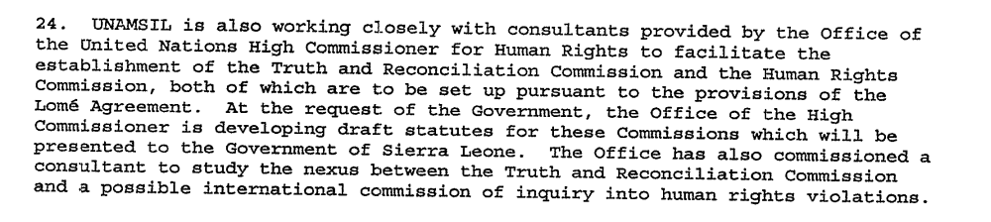
They [Malian President Alpha Oumar Konare and President Kabbah] also called for the immediate establishment of the commissions and committees provided for under the peace agreement, and especially the Human Rights Commission and the Truth and Reconciliation Commission.

Assessment

Short-term compliance
No or marginal compliance (1) | Medium low compliance (2) | x Medium high compliance (3) | Full or almost full compliance (4)

Considerations underlying the assessment

The Government of Sierra Leone moved quickly to try and establish these commissions. RUF did not show any participation in this process in the initial stages.

Medium-term compliance

Description of the addressee(s)’ conduct

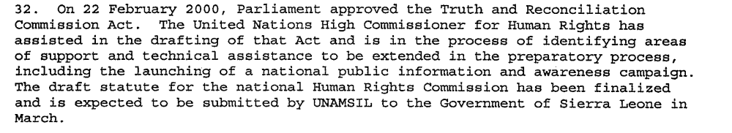
After a troubled start at the end of 2002, the TRC
appears to be on a solid footing.92 Statement-takers
have collected many statements from both victims
and perpetrators. A new executive secretary,
Franklyn Kargbo, and much of the permanent
secretariat staff were on board by the end of February
2003.93 Public hearings began in Freetown on 14
April, continued throughout the country and
concluded on 5 August. A TRC representative
expressed confidence that given adequate funds the
Commissioners will meet the original deadline of
October 2003 for submitting a final report.

Assessment

Medium-term compliance
No or marginal compliance (1) | Medium low compliance (2) | x Medium high compliance (3) | Full or almost full compliance (4)

Considerations underlying the assessment
The National Commission for Human Rights was not established within this time frame. The TRC was established, although it took far longer than was anticipated due- primarily- to funding constraints rather than commitment.

Depth of demand

Assessment

Level of depth of demand
Low depth of demand (1) | x Medium depth of demand (2) | High depth of demand (3)

Considerations underlying the assessment

It took a significant amount of resources to establish the TRC but it did not involve major changes to the parties’ behaviors.

Level of confidence about coding decisions

Level of confidence about coding decision
Extremely high | x High | Moderate

Comments to IPI (if any)

Civil war in Sierra Leone

UNSC Resolution: | 1260
Date of adoption: | 20 August 1999
Operative paragraph: | 12
Demand number: | 1

Megan MacKenzie

Wording of demand

design and implement programmes to address the special needs of war victims, in particular those who have suffered maiming mutiliation

List of addressees of the demand
Government of Sierra Leone

Short-term compliance

Description of the addressee(s)’ conduct

Minister of Foreign Affairs and International Cooperation Dr. Sama Banya has endorsed the creation of a Truth and Reconciliation Commission, a stipulation of the Lomé Peace Accord

The Minister of Development and Economic Planning, Dr. Kadi Sesay, said the rice [given as a gift by the Chinese government] would be sold through a process of competitive bidding, with the proceeds going to the establishment of a social security scheme. Sesay added that the scheme would provide assistance to the most vulnerable members of society, including the aged, orphans, amputees, and the very poor.

Assessment

Short-term compliance
No or marginal compliance (1) | x Medium low compliance (2) | Medium high compliance (3) | Full or almost full compliance (4)

Considerations underlying the assessment

There were many discussions about resource and programs for war victims but the social security scheme was one of the only concrete initiatives.

Medium-term compliance

Description of the addressee(s)’ conduct

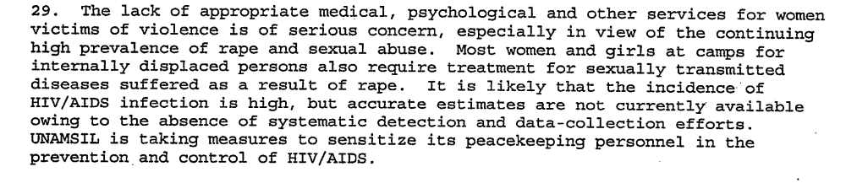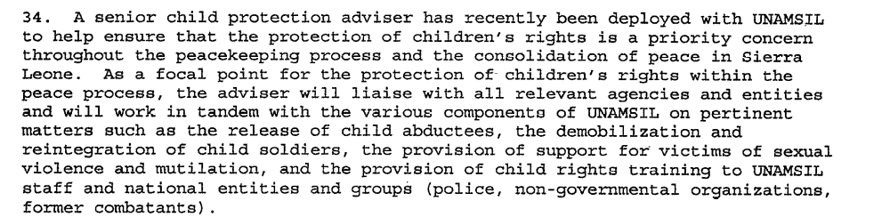

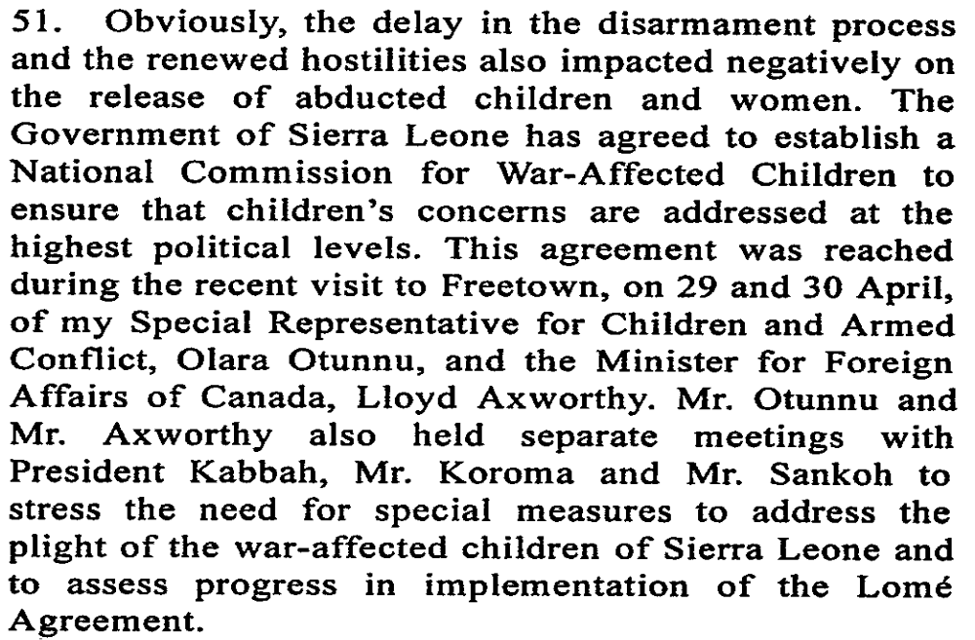

Assessment

Medium-term compliance
No or marginal compliance (1) | x Medium low compliance (2) | Medium high compliance (3) | Full or almost full compliance (4)

Considerations underlying the assessment

There is evidence that different victims groups- particularly women and children- did not receive sufficient attention or resources post-conflict.

Depth of demand

Assessment

Level of depth of demand
Low depth of demand (1) | x Medium depth of demand (2) | High depth of demand (3)

Considerations underlying the assessment
Such initiatives required substantial organization and resources at a time when the government was very limited in its capacities.

Level of confidence about coding decisions

Level of confidence about coding decision
Extremely high | x High | Moderate

Comments to IPI (if any)

Civil war in Sierra Leone

UNSC Resolution: | 1260
Date of adoption: | 20 August 1999
Operative paragraph: | 14
Demand number: | 2

Megan MacKenzie

Wording of demand

ensure the safe and unhindered access of humanitarian assistance to those in need in Sierra Leone, guarantee the safety and security of humanitarian personnel and respect strictly the relevant provisions of international humanitarian law

List of addressees of the demand
Government of Sierra Leone, Armed Forces Revolutionary Council, Civil Defence Forces , Revolutionary United Front

Short-term compliance

Description of the addressee(s)’ conduct

While Foday Sankoh remained in charge of the RUF, it continued to be an unreliable partner for peace. In the months following Lome [July 1999], the RUF became increasingly obstructionist, restricting the movement of UN troops and humanitarian staff in the rebel-controlled eastern and northern parts of the country. Cease-fire violations were common.

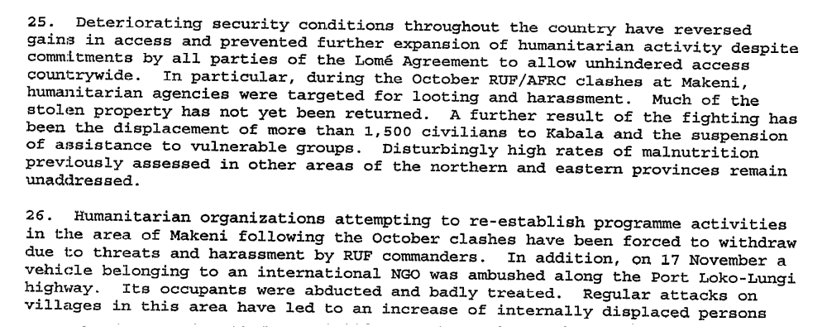

Assessment

Short-term compliance
x No or marginal compliance (1) | Medium low compliance (2) | Medium high compliance (3) | Full or almost full compliance (4)

Considerations underlying the assessment

There were serious threats and challenges to humanitarian workers and clear violations of human rights during this period.

Medium-term compliance

Description of the addressee(s)’ conduct

Human Rights Watch has documented serious abuses on the part of all parties to the conflict in Sierra Leone including some of those now fighting on the government side.
Recent reports have suggested that suspected members of the rebel Revolutionary United Front (RUF) have been summarily executed in Freetown in recent days. Human Rights Watch urged that the rights of captured combatants and suspected rebels be respected.

For the people of Sierra Leone, the civil war has never really ended," said Peter Takirambudde, executive director of the Africa division of Human Rights Watch. "The U.N. peacekeepers have suffered a terrible blow. But even after the peace agreement, people in villages all over the country have been subjected to rape, execution, torture, amputation and abduction by the rebels."

Assessment

Medium-term compliance
x No or marginal compliance (1) | Medium low compliance (2) | Medium high compliance (3) | Full or almost full compliance (4)

Considerations underlying the assessment

Human rights violations were reported throughout this period by various parties.

Depth of demand

Assessment

Level of depth of demand
Low depth of demand (1) | Medium depth of demand (2) | x High depth of demand (3)

Considerations underlying the assessment
Terrorizing civilians became a tactic of war for parties on all sides of the conflict. Ceasing such acts and allowing humanitarian workers to work and travel freely would have meant a considerable change in the parties’ behavior.

Level of confidence about coding decisions

Level of confidence about coding decision
Extremely high | x High | Moderate

Comments to IPI (if any)

Civil war in Sierra Leone

UNSC Resolution: | 1260
Date of adoption: | 20 August 1999
Operative paragraph: | 16
Demand number: | 1

Megan MacKenzie

Wording of demand

address the special needs of all children affected by the conflict in Sierra Leone, including through the disarmament, demobilization and reintegration programme and the Truth and Reconciliation Commission, and through support to child victims of mutilation, sexual exploitation and abduction, to the rehabilitation of health and education services, and to the recovery of traumatized children and the protection of unaccompanied children

List of addressees of the demand
Government of Sierra Leone

Short-term compliance

Description of the addressee(s)’ conduct
30 August to 4 September 1999
“The Special Representative undertook a mission to Sierra Leone â€” his third visit there â€” and Guinea from 30 August to 4 September 1999. He met with senior government officials, the Force Commander of the Monitoring Group (ECOMOG) of the Economic Community of West African States (ECOWAS), and representatives of the Revolutionary United Front (RUF). He also held discussions with the Special Representative of the Secretary-General for Sierra Leone, Francis Okelo, the United Nations country team, representatives of ICRC, local and international non-governmental organizations and a cross-section of civil society leaders.” He put forward an agenda that focused on various groups of vulnerable children including sexually abused children, child soldier, displaced children, war victims, amputees and abducted children.
3 December: About 158 former SLA troops, including 77 child soldiers, surrendered their weapons Thursday to the ECOMOG force at Laia Junction, the U.N. Integrated Regional Information Network (IRIN) reported on Friday, citing a United Nations Mission in Sierra Leone (UNAMSIL) source. The former combatants were said to be part of the SLA contingent based near Okra Hill.

Assessment

Short-term compliance
No or marginal compliance (1) | Medium low compliance (2) | x Medium high compliance (3) | Full or almost full compliance (4)

Considerations underlying the assessment
Although the response was not perfect, there were notable efforts on all sides to address the needs of children.

Medium-term compliance
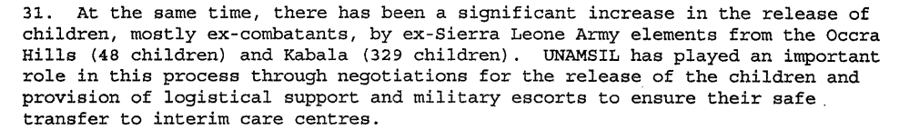

Description of the addressee(s)’ conduct

Assessment

Medium-term compliance
No or marginal compliance (1) | Medium low compliance (2) | x Medium high compliance (3) | Full or almost full compliance (4)

Considerations underlying the assessment
Children from all factions participated in the disarmament process and the special commission for war affected children was set up to address the needs of children post-conflict.

Depth of demand

Assessment

Level of depth of demand
Low depth of demand (1) | x Medium depth of demand (2) | High depth of demand (3)

Considerations underlying the assessment
In some cases, children made up a substantial portion of fighting forces groups. Allowing them to disarm and allocating a special commission for children demonstrated a change in attitude about the role of children in war.

Level of confidence about coding decisions

Level of confidence about coding decision
Extremely high | High | x Moderate

Comments to IPI (if any)

My hesitation with this demand comes from the number of recent resources indicating social problems in Sierra Leone because of the lack of attention to child soldiers post-conflict.

20- Youth unemployment remains extremely high as do
frustrations with government inefficiency.196
Educational opportunities are scarce, especially in the
provinces and for the poor. Instead of going to school
or working, many youths sit on street corners with
nothing to do and slim prospects.

United Nations Secretary General. Sixth report of the Secretary-General on UNOMSIL, including recommendations on future deployment 4 June 1999
United Nations Secretary General Seventh report of the Secretary-General on UNOMSIL, including recommendations on an expanded UNOMSIL presence 30 July 1999
United Nations Secretary General. Report of the Secretary-General on the establishment of a Special Court for Sierra Leone. 4 October 2000.
United Nations Secretary General. Sixth report of the Secretary-General on UNOMSIL, including recommendations on future deployment 4 June 1999
United Nations Secretary General Seventh report of the Secretary-General on UNOMSIL, including recommendations on an expanded UNOMSIL presence 30 July 1999
United Nations Secretary General Third report of the Secretary-General covering developments since the second report on UNAMSIL and containing a section describing important objectives of the peace process 7 March 2000
United Nations Secretary General. Fourth report of the Secretary-General on UNAMSIL 19 May 2000
United Nations Secretary General. Sixth report of the Secretary-General on UNOMSIL, including recommendations on future deployment 4 June 1999
Eric G. Berman and Melissa T. Labonte, “Sierra Leone” in William J. Durch ed. Sierra Leone 21st Century Peace Operations. (Washington: United States Institute of Peace) p160.
Rebels Demand Sankoh Release http://news.bbc.co.uk/2/hi/africa/755486.stm 19 May 2000 (retrieve 2 August 2009)
Kofi Annan. Ninth Report of the Secretary-General on the United Nations Mission in Sierra Leone http://www.afrol.com/html/Countries/Sierra_Leone/documents/un_sg_140301.htm 14 March 2001
Dennis Bright. September 2000. Conciliation Resources. Implementing the Lome Peace Agreement. http://www.c-r.org/our-work/accord/sierra-leone/implementing-lome.php (retrieved 29 August 2009)
United Nations Secretary General Seventh report of the Secretary-General on UNOMSIL, including recommendations on an expanded UNOMSIL presence 30 July 1999
Sierra Leone Rebels Reach an Agreement http://www.int.iol.co.za/?set_id=1&click_id=68&art_id=qw930545700335B245 June 28, 1999 Independent Online (retrieved 12 August 2009)
Rebels Demand Sankoh Release http://news.bbc.co.uk/2/hi/africa/755486.stm 19 May 2000 (retrieve 2 August 2009)
Kofi Annan. Ninth Report of the Secretary-General on the United Nations Mission in Sierra Leone http://www.afrol.com/html/Countries/Sierra_Leone/documents/un_sg_140301.htm 14 March 2001 (retrieved 13 August 2009)
Eric G. Berman and Melissa T. Labonte, “Sierra Leone” in William J. Durch ed. Sierra Leone 21st Century Peace Operations. (Washington: United States Institute of Peace) p161.
Atrocities Continue in Sierra Leone October 28 1999 BBC (retrieved 12 August 2009) http://news.bbc.co.uk/2/hi/africa/491103.stm
United Nations Secretary General First report of the Secretary-General on UNAMSIL 6 December 1999
Sierra Leone one year after the peace accord http://www.afrol.com/Countries/Sierra_Leone/backgr_peace_conference.htm Partnership Africa Canada (retrieved 20 August 2009)
Eric G. Berman and Melissa T. Labonte, “Sierra Leone” in William J. Durch ed. Sierra Leone 21st Century Peace Operations. (Washington: United States Institute of Peace) p160.
Jane Perlez. G.I.s to Be Sent to Train Africans for Sierra Leone 9 August 2000 http://www.nytimes.com/2000/08/09/world/gi-s-to-be-sent-to-train-africans-for-sierra-leone.html (retrieved 1 August 2009)
International Crisis Group. Sierra Leone: Time for a New Military and Political Strategy. ICG Africa Report No 28. Freetown/London/Brussels. 11 April 2001.
International Crisis Group. Sierra Leone: Time for a New Military and Political Strategy. ICG Africa Report No 28. Freetown/London/Brussels. 11 April 2001.
21st century peace operations Sierra Leone Eric G. Berman and Melissa T. Labonte May 2000 RUF rebels took over 400 UN peacekeepers hostage p141
Sierra Leone Web. Sierra Leone News http://www.sierra-leone.org/Archives/slnews0600.html
21st century peace operations Sierra Leone Eric G. Berman and Melissa T. Labonte May 2000 RUF rebels took over 400 UN peacekeepers hostage p161
Jane Perlez. G.I.s to Be Sent to Train Africans for Sierra Leone 9 August 2000 http://www.nytimes.com/2000/08/09/world/gi-s-to-be-sent-to-train-africans-for-sierra-leone.html (retrieved 1 August 2009)
United Nations Secretary General First report of the Secretary-General on UNAMSIL 6 December 1999
Sierra Leone Web 28 May 2000 http://www.sierra-leone.org/Archives/slnews0500.html (retrieved 15 August 2009)
Sierra Leone Web 20 May 2000 http://www.sierra-leone.org/Archives/slnews0500.html (retrieved 15 August 2009)
United Nations Secretary General First report of the Secretary-General on UNAMSIL 6 December 1999
Gberie, Lansana. A Dirty War in West Africa: The RUF and the Destruction of Sierra Leone. Bloomington and Indianapolis: Indiana University Press, 2005. p163-164
Neglected Arms Embargo on Sierra Leone Rebels. Briefing Paper 15 May 2000 Human Rights Watch http://www.hrw.org/legacy/english/docs/2000/05/25/sierra3077_txt.htm
United Nations Secretary General First report of the Secretary-General on UNAMSIL 6 December 1999
Sierra Leone web News http://www.sierra-leone.org/Archives/slnews0100.html 25 January 2000
International Crisis Group. Sierra Leone: The State of Security and Governance. ICG Africa Report No 67. Freetown/London/Brussels. 3 September 2003. P11
Sierra Leone Web 30 January 2000 http://www.sierra-leone.org/Archives/slnews0100.html
Sierra Leone Web 10 January 2000 http://www.sierra-leone.org/Archives/slnews0100.html
United Nations Secretary General. Third report of the Secretary-General covering developments since the second report on UNAMSIL and containing a section describing important objectives of the peace process 7 March 2000.
United Nations Secretary General. Fourth Report of the Secretary General on UNAMSIL. 19 May 2000.
Eric G. Berman and Melissa T. Labonte, “Sierra Leone” in William J. Durch ed. Sierra Leone 21st Century Peace Operations. (Washington: United States Institute of Peace) p161.
United Nations Secretary General First report of the Secretary-General on UNAMSIL 6 December 1999
Human Rights Watch. 11 May 2000/ New Peacekeeping Authority Needed in Sierra Leone http://www.hrw.org/en/news/2000/05/11/new-peacekeeping-authority-needed-sierra-leone
Civilians the Real Target in Sierra Leone 4 May 2000 Human Rights Watch http://www.hrw.org/en/news/2000/05/04/civilians-real-target-sierra-leone
United Nations Special Envoy for Children and Armed Conflict. Sierra Leone. 30 August to 4 September 1999. http://www.un.org/esa/africa/child/sierra_files/Home_files/Main.cfm (retrieved 2 September 2009)
Sierra Leone Web. Sierra Leone News Archives 1999. 3 December 1999 http://www.sierra-leone.org/Archives/slnews1299.html (retrieved 14 August 2009)
United Nations Secretary General. Third report of the Secretary-General covering developments since the second report on UNAMSIL and containing a section describing important objectives of the peace process 7 March 2000.
United Nations Secretary General. Fourth Report of the Secretary General on UNAMSIL. 19 May 2000.
International Crisis Group. Sierra Leone: The State of Security and Governance. ICG Africa Report No 67. Freetown/London/Brussels. 3 September 2003. P23

